- Create the tables below in the database. Use foreign keys and primary keys as required.
  - Create a table called as student with the following columns student_id, first_name, last_name ,birthdate , department_id ,address_id .
  - Create Address table with following columns address_id , street_address, city, State, postal_code
  - Create department table department_id, department name. Make sure you are using the right data type against all the columns.

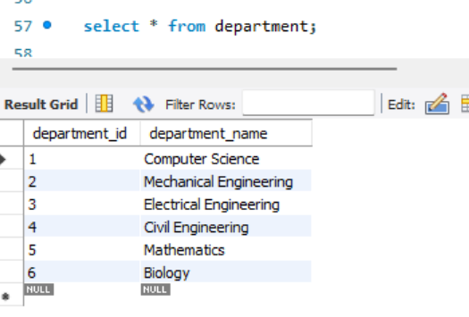

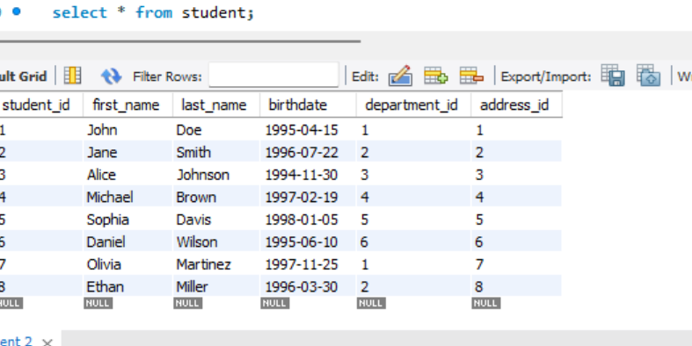

- Use Sample data from sampledata.txt to insert data into the database
- Write a query to find the total number of students.
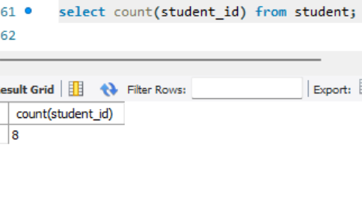
- Write a query to find which department john belongs to.

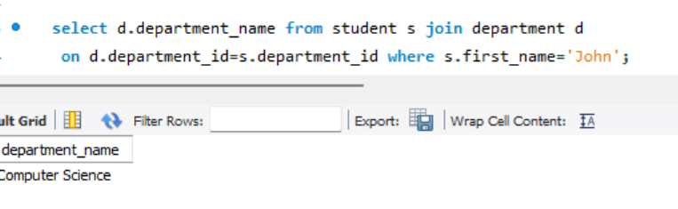
- List All Departments with Their Number of Students (Including Departments with No Students)
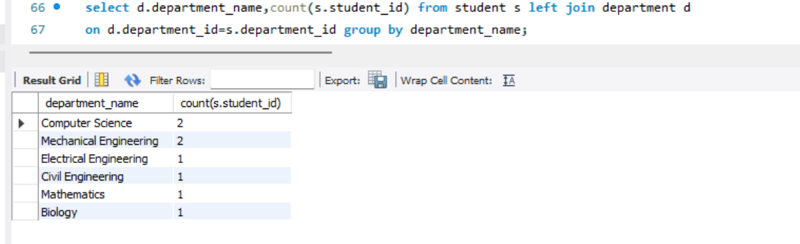
- Select all students with their department and address.
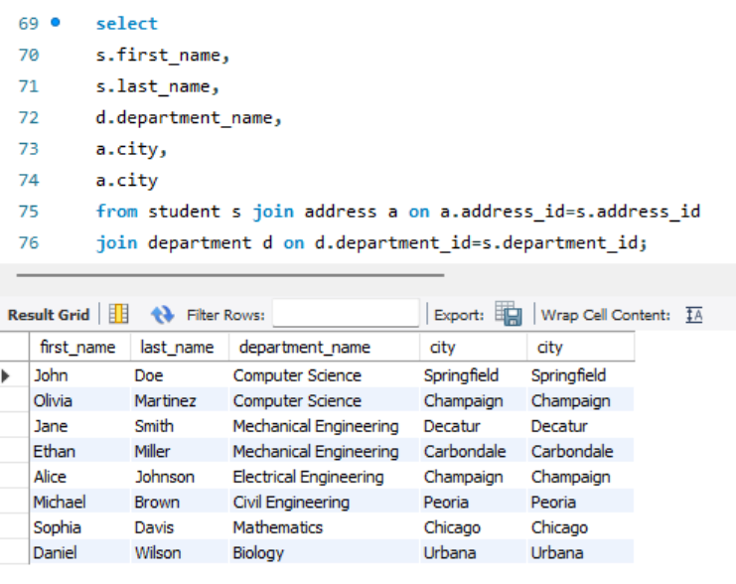
- Find all students who are in the 'Computer Science' department
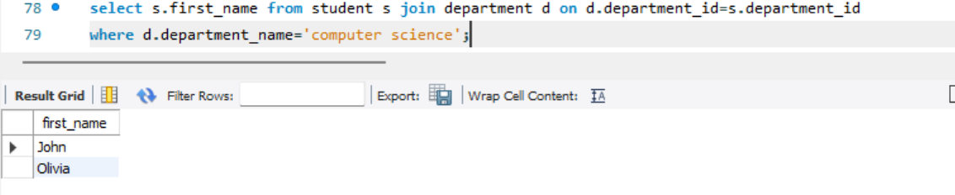
- Update Jane’s city name to New York.
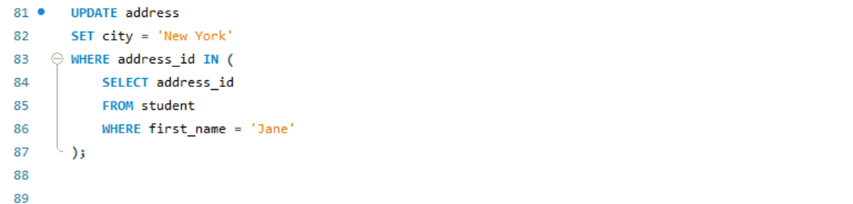
- Delete a student from the student table.
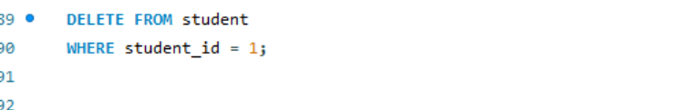
- Select all students with their department and address in New York.

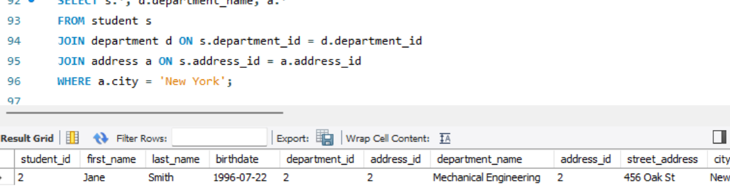
- Count how many students are in each department
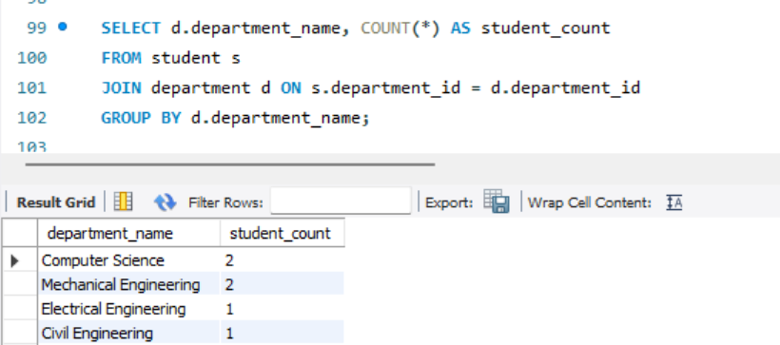
- Find students who live in 'Springfield'
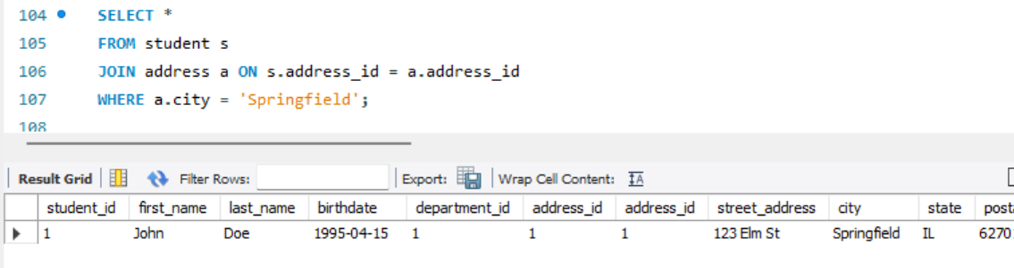
- Select students whose birthday falls in February
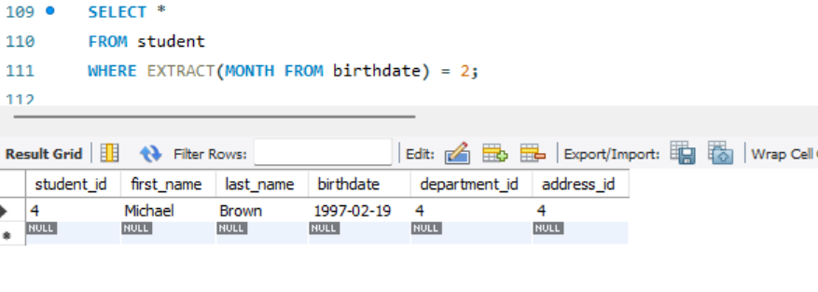
- Get the department and address details for a specific student, example john
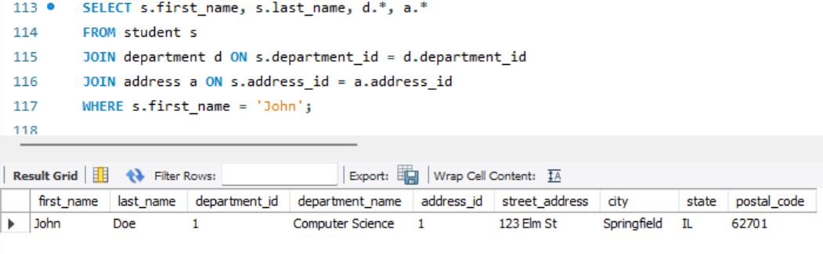
- Find all students who are born within 1995 to 1998
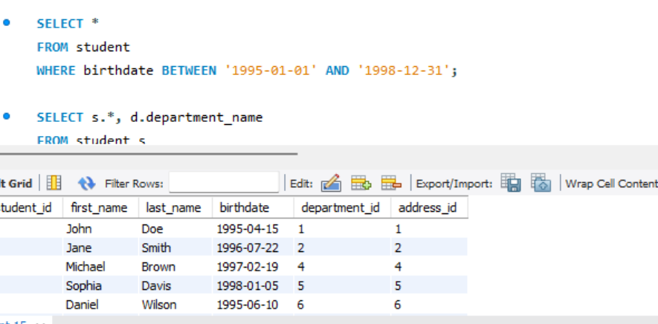
- List all students and their corresponding department names, sorted by department
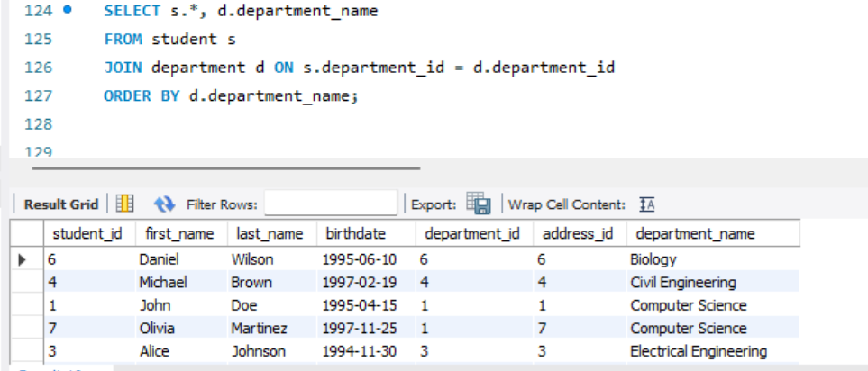

- Find the number of students in each department who are living in 'Champaign'

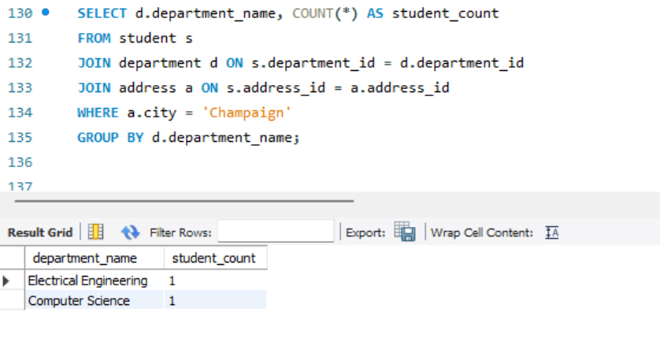
- Retrieve the names of students who live on 'Pine' street
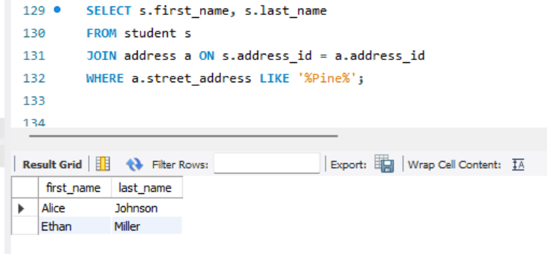
- Update the department of a student with student_id = 6 to 'Mechanical Engineering'
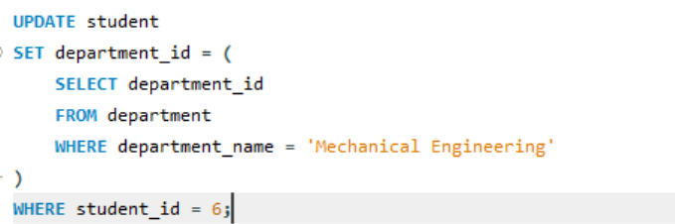
- Find the student(s) who live in the city 'Chicago' and are in the 'Mathematics' department
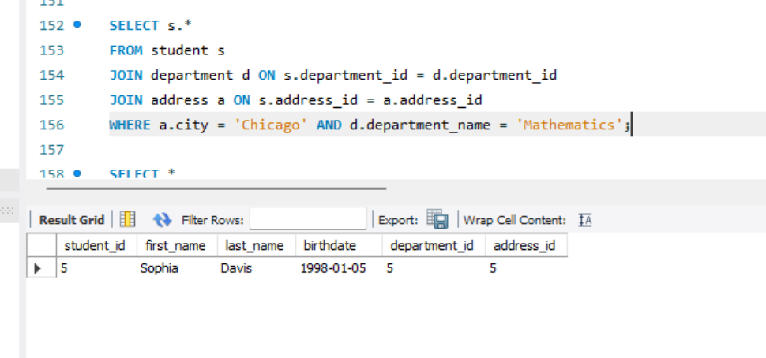
- List all students who have an address in 'Urbana' or 'Peoria'
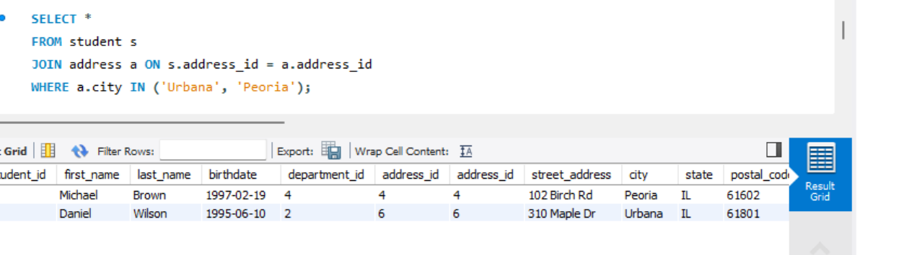

- Find the student with the highest student_id
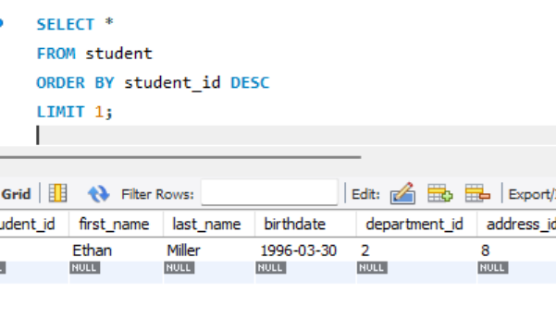
- Find all students who are not in the 'Computer Science' department
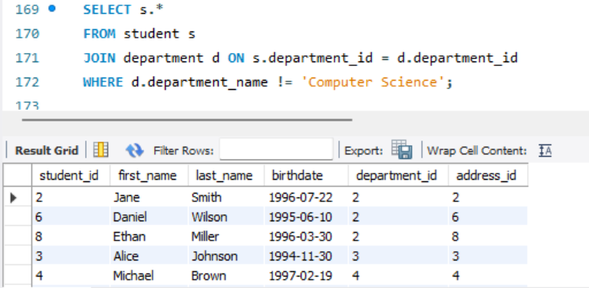
- Count the total number of addresses in the 'Champaign' city
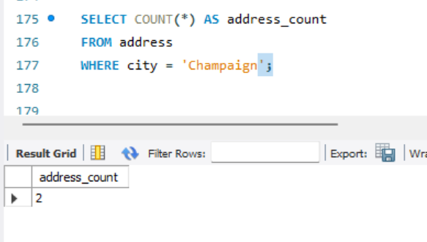
- Find the name of the student who lives at '520 Pine Rd' .
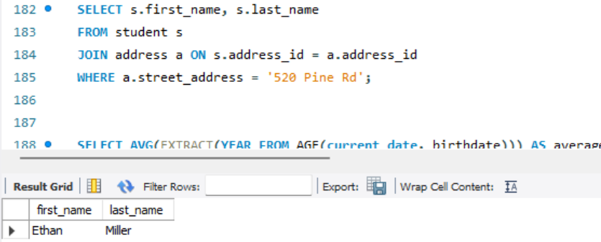
- Get the average age of students in the 'Electrical Engineering' department
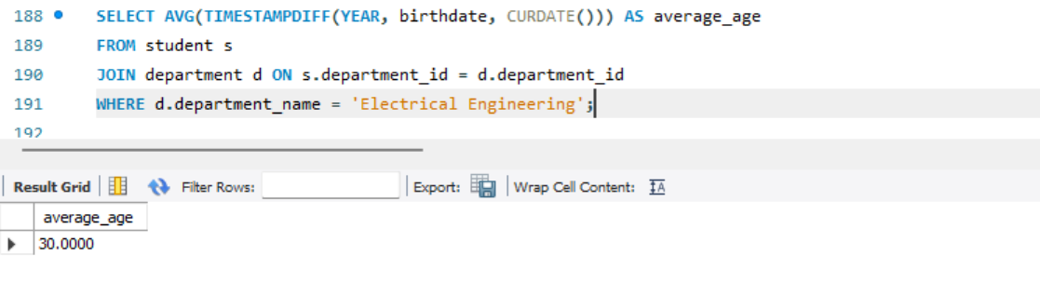
- List the students, their department, and the city where they live, but only for those in departments starting with 'M'

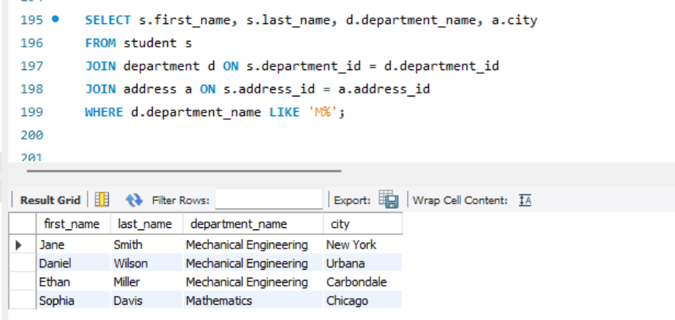
- Delete a student from the 'Mechanical Engineering' department

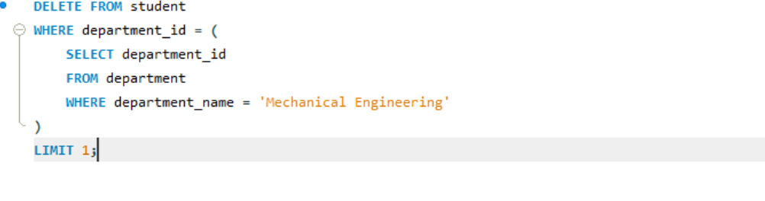

Download order.sql
Open PG Admin and open query tool and select any database of your choice.
Click on “Open file” and select order. SQL from your device and execute it.
Questions:
- Retrieve All Orders with Their Customer Details and Current Status
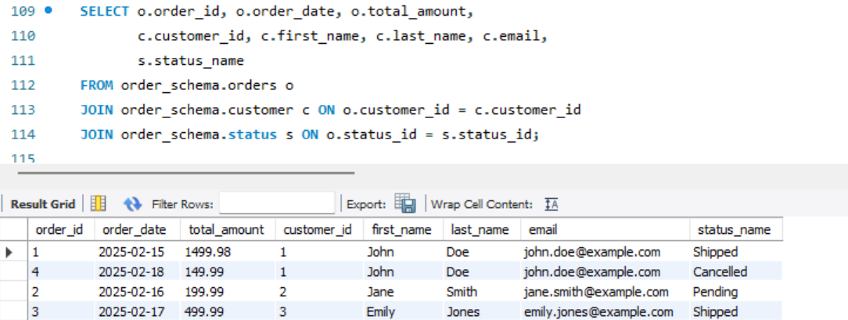

- Get the Total Value of Orders for a Given Customer in a Specific Time Period
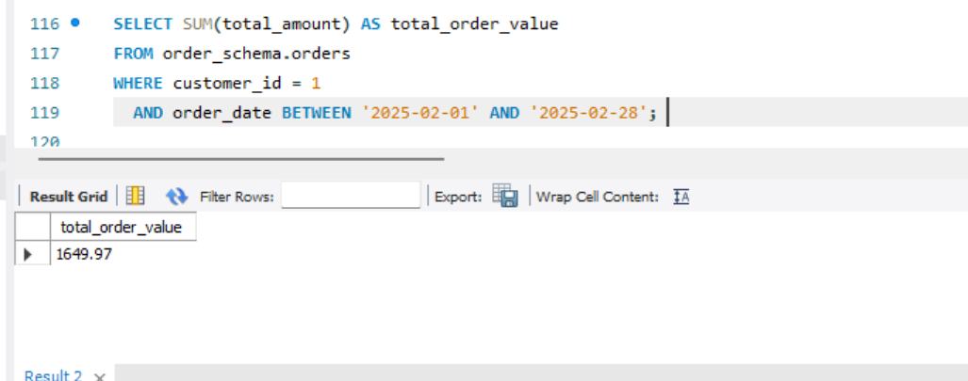
- Find the Most Expensive Order by Customer

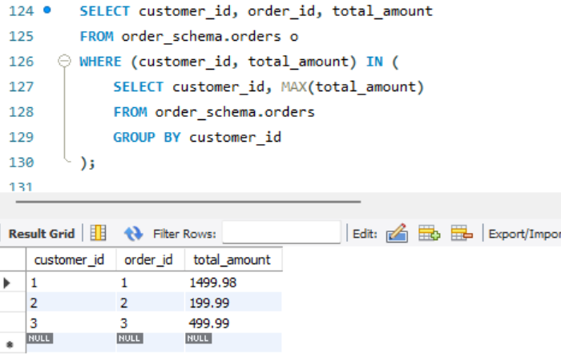
- Find the Total Revenue for Each Product Based on Orders
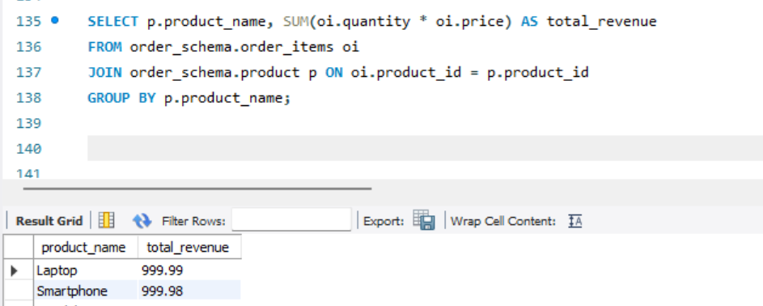
- Write a query to retrieve the order ID, customer ID, and the total amount of each order. If the total amount is null, display '0.00' instead.
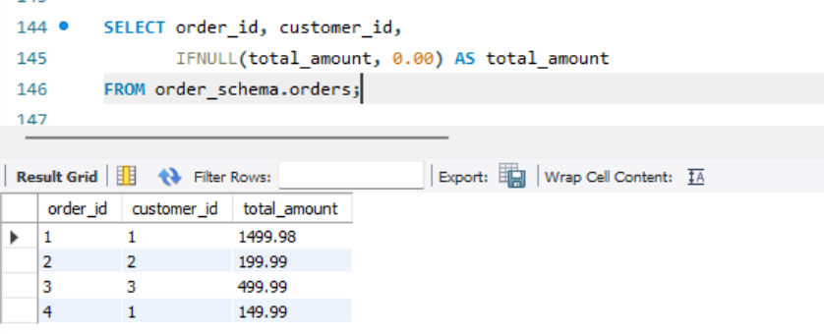
- Retrieve the Order History of a Specific Customer Along with Product Details
- Get the Average Order Value Per Customer in the Last 30 Days.
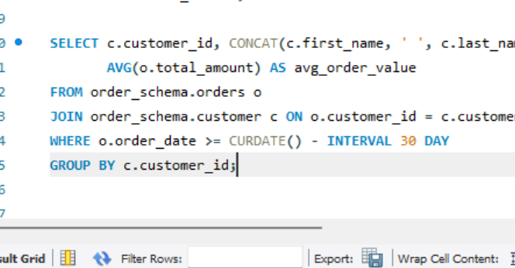
- Get the Top 5 Products with the Highest Number of Orders.
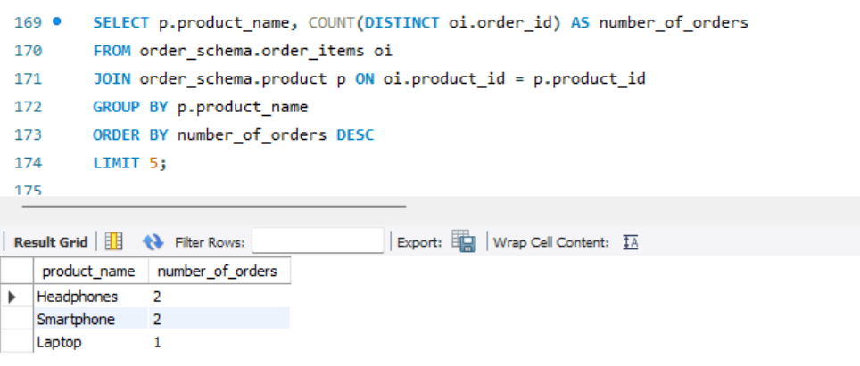
- Get the Customers Who Have Not Placed Any Orders in the Last 60 Days
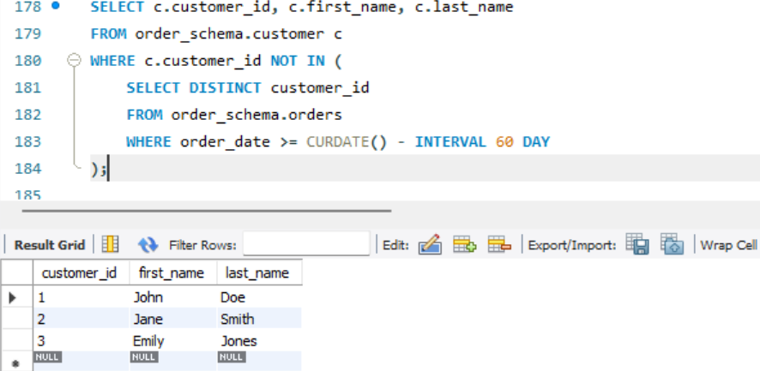
- List the Orders with Products Ordered More Than Once, Sorted by Order Date
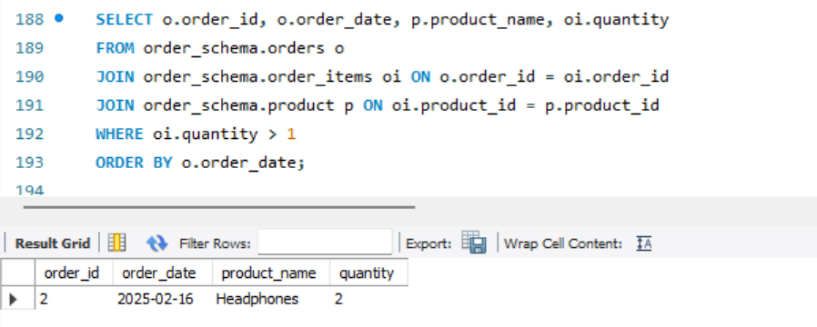
- Retrieve the Number of Orders and Total Revenue for Each Status
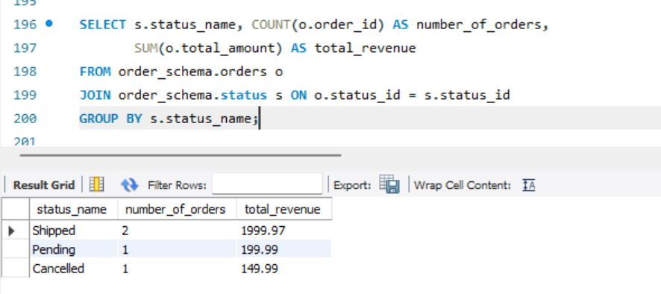
- Find Customers Who Have Ordered More Than a Specific Product (e.g., "Laptop")
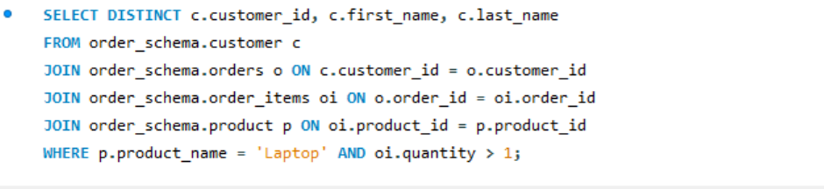
- Find the Products That Have Never Been Ordered
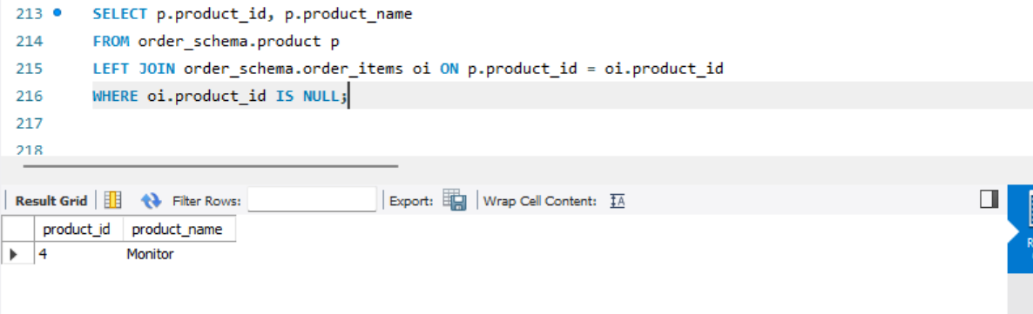

- Get the Total Quantity of Products Ordered in the Last 7 Days
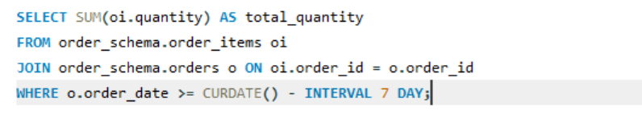
- Create a view named product_details that includes all columns from the product table.
- Create a view named order_summary that includes the order_id, customer_id, order_date, total_amount, and status_name (from the status table) for each order.

